VIBES
AWARDS
2015
VISION IN BUSINESS FOR THE ENVIRONMENT OF SCOTLAND

CIRCULAR ECONOMY AWARD
APPLICATION FORM

CONTENT
01.0 Basic Information
Main Business Activity
01.1 Contact Information
01.2 European Awards
02.0 Judging Criteria
Executive Summary
02.1 Commitment
02.2 Innovation
02.3 Environmental Benefit
02.4 Social Benefit
02.5 Economic Benefit
02.6 Best Practice
03.0 Partners & Sponsors
04.0 Submission Details

Please read the guidance notes provided on the VIBES Website www.vibes.org.uk before completing the sections below.

How does it work?
The VIBES (Vision in Business for the Environment of Scotland) Awards aim to raise awareness of environmental and sustainable development¹ issues within businesses in Scotland.
¹ “Development that meets the needs of the present without compromising the ability of future generations to meet their own needs” (Bruntland Report definition) i.e. takes consideration of social, economic and environmental issues
The competition emphasises that best environmental practice is not only good for business, the economy and competitiveness but also benefits the surroundings in which we work, live and relax. It will reward those who have addressed sustainable development issues in the work place and encourage others to follow their example.

The Circular Economy Award recognises businesses that can demonstrate a circular approach to material use and business function.
This category is aimed at businesses that can demonstrate how their product or services address the principles of the Circular Economy, which should include one or more of the following elements:
- Circular product design and innovation
- Product re-use, repair and remanufacturing
- Innovative business models
- Materials substitution
- Effective supply chain and cross-sectoral collaboration
- Re-use of waste, heat and energy.

A Circular Economy approach ensures that materials are retained within productive use, in a high value state, for as long as possible. It focuses on reshaping business and economic systems so that waste is ‘designed out’ of how we live. This approach is illustrated below.
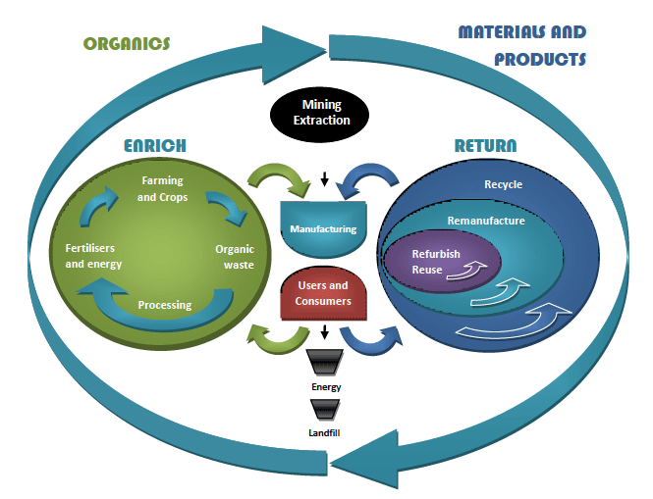

The application form can be downloaded as a word version from www.vibes.org.ukcompleted electronically and submitted via e-mail to vibes@sepa.org.uk
We encourage entries to be made via e-mail whenever possible alternatively it can be typed or completed in clear handwriting and sent to the address at the back of the form.
All the forms we receive will be assessed, and those which show a high level of commitment and have reached the appropriate standard will be added to the list of finalists.
If you are placed on the list of finalists you will then receive a judge’s site visit. This gives you the opportunity to provide more details of your achievements and allows the judges to more accurately assess your application.
If your company has previously applied for or won a VIBES award it is important that you can demonstrate continuous or additional improvement from the time of previous application.
Please note we are limiting the finalists to a maximum of 5 per category for 2015.

01.0 Basic information

Company Name *

Candidate site *

Number of company sites*

Is your Company part of a larger group?* | Yes | No
If yes to the above please provide name of the group*
Are you classed as a small to medium sized enterprise (SME)** | Yes | No
Number of Employees at site *
Number of Employees in group *
*This information must be completed for a successful application
** Definition of SME = Less than 250 employees

Main Business Activities | Judges use only
Please describe briefly the main business activities taking place at the site

This should state your main business activity, the services or products you provide and your principal markets. This summary is limited to 100 words

Please identify word count in this box

01.1 Contact Information

Site contact *

Job title *

Telephone number * *
Email address *
Website *
Correspondence address including postcode *

These awards act as a participating feeder scheme for the European Business Awards for the Environment (EBAE)
If you are successful with your VIBES entry we will provide you with further information on the EBAE. You can also read more about the European awards by visiting their website at: www.ec.europe.eu/environment/awards
01.2 EUROPEAN AWARDS

Are you happy for your application to be put forward as a potential UK entry?

Yes | No
Have you applied for a VIBES award previously? If so – when.

Where did you hear about the VIBES Awards?

Please note that by entering VIBES you agree to share the information you provide with the partner organisations for judging purposes only.
The Partner Organisations are;
Energy Saving Trust; Highlands and Islands Enterprise; Scottish Environment Protection Agency; Scottish Enterprise; Scottish Water; Scottish Government; Zero Waste Scotland; 2020 Climate Group
We may ask the partner organisations for additional information. This information will only be used to help assess your suitability as a VIBES winner.
If you’re successful with your entry we will prepare a case study to highlight the areas of your business that particularly impress the judges. Once you have approved the content of the case study this will be used to promote good practice more widely.

Partner organisations, sponsors and supporting organisations may contact you with further information that they consider may be appropriate. Please indicate if you do not want to receive this information. An updated list of sponsors can be found on the VIBES website www.vibes.org.uk

Sponsor Organisations: Scottish Power
Brandrex
Zero Waste Scotland
Pernod Ricard
The Scottish Government
The University of Stirling Management School
EMEC

Supporting Organisations: Bright Green Business
Federation of Small Businesses
Institute of Directors
CBI Scotland

Please tick if you do not wish to receive information from partner organisations
Please tick if you do not wish to receive information from sponsors organisations
Please tick if you do not wish to receive information from supporting organisations

PART 2 – JUDGING CRITERIA

We would like you to provide information on your company’s commitment to improving environmental performance, including actions and achievements. To help us assess your entry please supply details against the following criteria (see guidance notes section 6 for further information).
Executive Summary | Judges use only
Please explain why you are applying for this award outlining what you have done, what you have achieved, innovations, originality and inspiration for the changes.
This summary is limited to 500 words

Please identify word count in this box

02.1 CRITERIA  Please identify word count in this box | Commitment (250 words max)  Senior management must be clearly committed to the development and marketing of the product or service. The importance in the context of the organisations overall strategy must be clear | Judges Use Only

02.2 CRITERIA  Please identify word count in this box | Innovation (250 words max)  Innovation in the product or service must bring improvements in environmental performance over comparable alternatives and promote more eco-efficient production

02.3 CRITERIA  Please identify word count in this box | Environmental Benefit (250 words max)  Clear and quantifiable analysis must demonstrate the reduced environmental impact over the complete life-cycle of the service or product.  Please provide environmental data for 3 years if possible, and be sure to include the correct units where applicable | Judges Use Only

02.4 CRITERIA  Please identify word count in this box | Social Benefit (250 words max)  The product/service should meet the needs of consumers, staff, and communities and bring wider social benefits. | Judges use only

02.5 CRITERIA  Please identify word count in this box | Economic Benefit (250 words max)  Proof must be provided to demonstrate that the new product/ service is economically viable.  Please ensure that economic benefit data provided relates specifically to the environmental benefit data provided in the previous section.  Please provide data for three years if possible | Judges Use only

02.6 CRITERIA  Please identify word count in this box | Best Practice (250 words max)  There must be clear potential for good practice and innovation to be replicated elsewhere (e.g. through involvement in business networks, dissemination at conferences). | Judges use only

- 03.0 PARTNERS & SPONSORS

Have you had contact with any of the VIBES Awards partners in the past? (If so, please state)
Are you happy to be contacted by the VIBES partners and sponsors in the future to offer more advice? (If so, please state)

- - 04.0 SUBMISSION DETAILS
To submit your completed application save this word document using your company as the file name (if saving as PDF please also provide a word version). Then electronically submit your application to us at the email address below.

Email Submission
vibes@SEPA.org.uk

Further Assistance
T/01896 754797
vibes@sepa.org.uk
www.vibes.org.uk
Scottish Environment Protection Agency
VIBES Awards
Burnbrae
Mossilee Road
Galashiels
TD1 1NF

VIBES is a partnership between
- Energy Saving Trust
Highlands and Islands Enterprise
Scottish Environment Protection Agency
Scottish Enterprise
Scottish Water
Scottish Government
Zero Waste Scotland
2020 Climate Group
VIBES is supported by
CBI Scotland
Institute of Directors
Bright Green Business
FSB

Good luck from the whole team!

