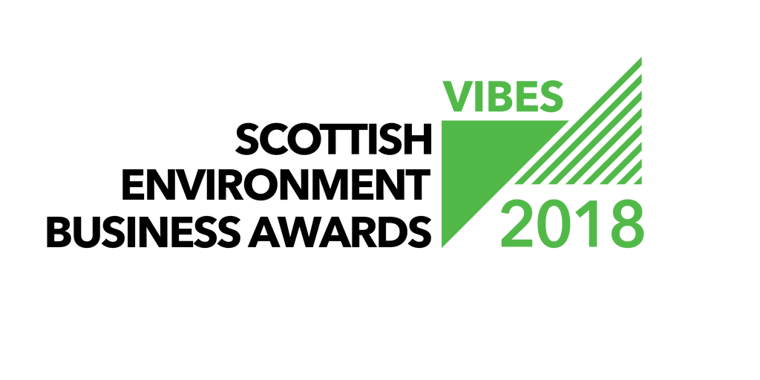

GREEN TEAM AWARD

APPLICATION FORM

2018

Contents

1. General Information 2
2. Entry Form 4
3. Special Award - Adaptation 6
4. Additional Award Categories 8
5. What next? 9
6. EBAE Awards 9
7. Partners & Sponsors 9
8. Submission Details 11

General Information

Welcome to the VIBES – Scottish Environment Business Awards 2018. The awards aim to emphasise that best environmental practice is not only good for business, the economy and competitiveness, but that it also benefits the surroundings in which we work, live and relax. VIBES rewards those who have addressed sustainable¹ development issues in the work place and encourages others to follow their examples.
¹ “Development that meets the needs of the present without compromising the ability of future generations to meet their own needs” (Bruntland Report definition) i.e. takes consideration of social, economic and environmental issues.
The Green Team Award rewards organisations that have recognised the importance of working as a team to deliver environmental improvements. A green team can be within an organisation or between organisations.
This award can apply to organisations (public and private sector) or collaboration between different organisations to achieve efficiencies.
- A successful green team comprises people from different departments and levels of seniority. This helps to ensure that ideas are varied and dynamic.
- They require senior management support to enable their recommendations and improvements to be implemented and also to have time within their work to dedicate to the green team.
- Key attributes needed from green team members are enthusiasm, motivation and the ability to influence others.
- Team members do not have to be ‘green’. Indeed, those who understand the commercial imperative of resource efficiency can be powerful in motivating others to act who have similar attitudes.
Benefits that a green team can offer can include:
- Cost savings – reducing costs associated with waste, energy, and water.
- Attracting and retaining talent – Transferable skills, improves employee morale and satisfaction, reduces staff absenteeism.
- Influences others – at work, at home and their communities
- Customer expectations and demands – strengthening brand and increasing market share.
- Avoid risks of inaction – costs, damage to reputation, loss of competitive advantage
- Regulatory compliance – staying ahead of legislation.
- Aligning practices with values – walking the talk.
- Sharing best practice – within the organisation and to a wider audience.

Please note, in addition to applying for this award, there is an opportunity to win a special award for adaptation to climate change through adding some additional information to this form.
Has your business taken action to identify and manage climate related risks? Or developed products and services that will help society adapt? If so then apply for the Special award for adaptation.

About adapting to climate change
Adapting to climate change includes:
- Being aware of how changes in climate will affect your business and taking action to manage risks and adapt.
- Developing products and services that will help society to adapt, or those that become viable as our climate changes.

How is the climate changing?
Over the last few decades Scotland’s climate has warmed, sea-levels have risen, rainfall patterns have changed and we have been impacted by more extreme weather events. Efforts to reduce greenhouse gas emissions will limit the amount of future climate change but we cannot stop the changes that have already begun. Past and present day emissions mean that changes in Scotland’s climate will continue and increase in the decades ahead with serious implications for business.

What do these changes mean for businesses?
Increased damage to premises, disruption and volatility in supply chains and business continuity issues are all likely to increase as the impacts of climate change increase. Planning for these challenges should be included in business planning today.

Changes in climate are also increasing demand for products and services that help society increase resilience and adapt, as well as creating or enhancing other market opportunities. Business will lead the way in developing these products and services.

Take a look at Climate Ready Business guidance to find out more about adapting to climate change.

Entry Form

Company Name
Candidate site*
(location for site visit judging)
Number of sites*
Number of employees at site*
Is your company part of a larger group?*
If yes, please provide the name of the larger group*
Number of employees in group*
Are you classed as a small to medium sized enterprise (SME)?**
Have you applied for a VIBES award previously?
What is your industry SIC code?
If ‘yes’, when and which award(s)?
Where did you hear about the VIBES – Scottish Environment Business Awards?
* These boxes must be completed
** SMEs are defined as having less than 250 employees.

Main Business Activities
Please describe briefly the main business activities taking place at the site.

This section should include details of your main business activity, the services or products you provide and your principal markets. This summary is limited to 100 words.

CONTACT INFORMATION
Site Contact*
Job Title*
Telephone Number*
Email Address*
Website*
Correspondence Address Including Postcode*
* These boxes must be completed

GREEN TEAM
Please explain
- Why you are applying for this award
- How your green team is set up and who is involved
- How your green team has changed behaviours
- Quantify how the green team has achieved environmental, social and economic benefit.

This section is limited to 500 words.

Special Award - Adaptation

Please complete if you wish to be considered for a special award for adaptation.
This Special award recognises businesses and partnerships that are taking a proactive approach to managing climate risks and/ or developing products and services that are enabling society to adapt. This could be through:

- Completing climate risk assessments for different business functions/ locations
- Implementing actions to adapt – this could include awareness raising and capacity building as well as delivering ‘on the ground’ actions
- Working with industry bodies to assess and manage risks that affect business sectors
- Developing innovative products and services that are enabling clients to assess and manage climate risks
- Developing innovative products and services that support adaptation action
- Assessing and driving adaptation through supply chains

Adaptation
Please explain
- How you are managing and developing your business to adapt to climate change.

This section is limited to 250 words.

Additional Award Categories

Do you want to apply for another award category? If so please tick the category/ categories you would like to apply for: Please provide any additional information that you think will support your application.
 | Management (Large or SME) |  | Sustainable and Active Travel
 | Environmental Product or Service |  | Circular Economy
 | Innovation |  | Hydro Nation Water Innovation
Information to support additional award category/ categories
This section is limited to 500 words per category.

What next?

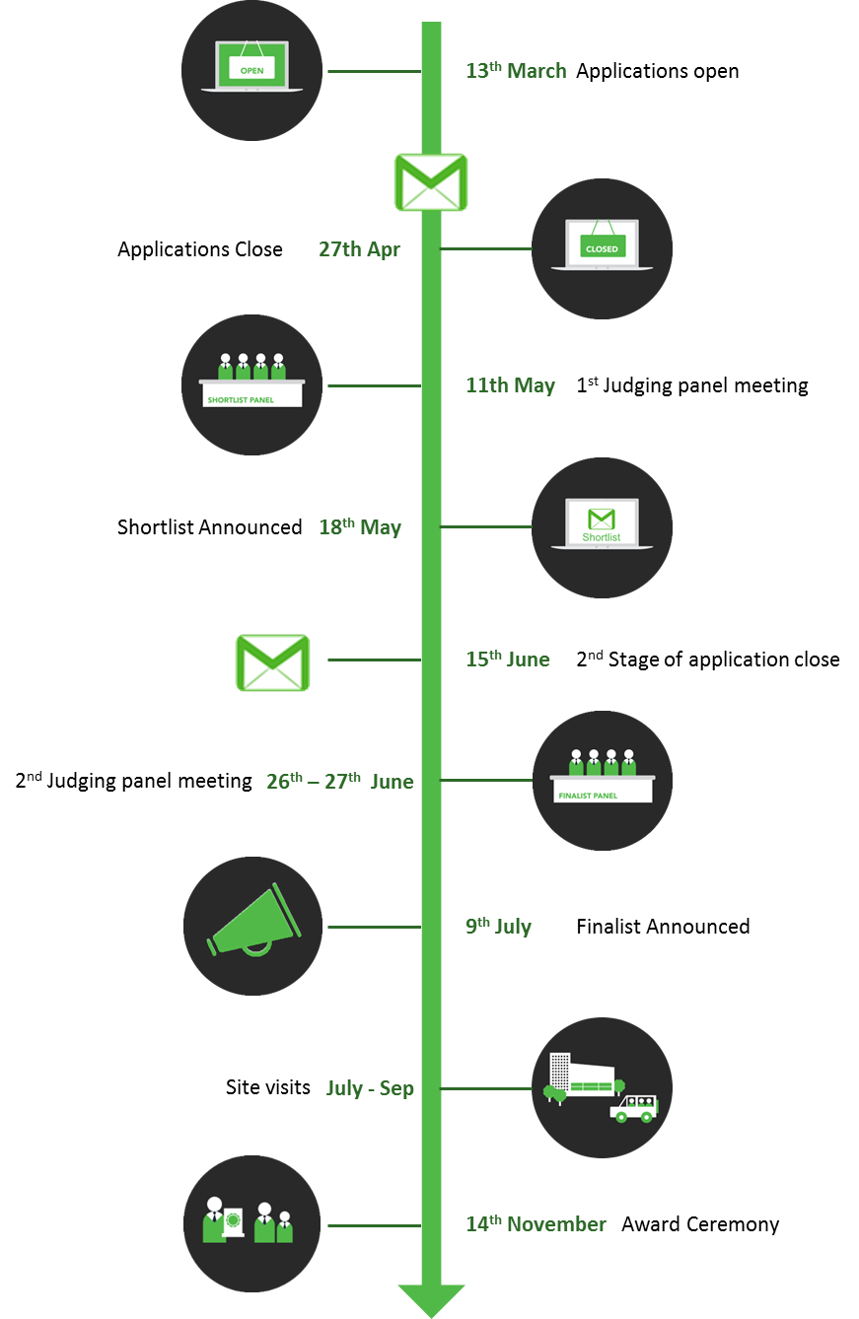
All the forms we receive will be assessed, and the 10 entrants that best demonstrate how their Green Team has achieved environmental, social and economic benefits and have reached the appropriate standard will be shortlisted and invited to provide further information.
This information will be reviewed and top 5 will be finalists you will then receive a judge’s site visit. This gives you the opportunity to provide more details of your achievements and allows the judges to more accurately assess your application.
If your company has previously applied for or won a VIBES award, it is important that you can demonstrate continuous or additional improvement from the time of your previous application.
Please note we are limiting the shortlist to a maximum of 10 per category and the finalists to a maximum of 5 per category for 2018.

EBAE Awards

These awards act as a participating feeder scheme for the European Business Awards for the Environment (EBAE).
If you are successful with your VIBES – Scottish Environment Business Awards entry we will provide you with further information on the EBAE. You can read more about the European awards by visiting their website at: http://ec.europa.eu/environment/awards/index.html.
AWARDS
Are you happy for your application to be put forward as a potential UK entry for EBAE?

Partners & Sponsors

Please note that by entering VIBES – Scottish Environment Business Awards you agree to share the information you provide with the partner organisations for judging purposes.
We may ask partner organisations for additional information. This information will only be used to help assess your suitability as a VIBES – Scottish Environment Business Awards winner.
If you’re successful with your entry, we will prepare a case study to highlight the areas of your business that particularly impressed the judges. Once you have approved the content of the case study, it will be used to promote good practice more widely.
The partner organisations are:
- Energy Saving Trust
- Highlands and Islands Enterprise
- Scottish Environment Protection Agency
- Scottish Enterprise
- Scottish Water
- Scottish Government
- Zero Waste Scotland
The Awards are supported by:
- CBI Scotland
- Institute of Directors
- Bright Green Business
- Federation of Small Businesses
- Quality Scotland
Partner organisations, sponsors and supporting organisations may contact you with further information that they consider may be appropriate. Please indicate if you agree to receive this information.
Please mark if you agree to receive information from partner organisations. | ☐
Please mark if you agree to receive information from sponsor organisations. | ☐
Please mark if you agree to receive information from supporting organisations. | ☐

To maximise promotional opportunities your application will be shared with our PR contractor, BIG Partnership, who will be in touch with you for approval, should they wish to use any content from your entry in the media. This will result in press coverage for your business. Please tick box to agree to this.
Please mark if you agree to share your application with our PR contractor under conditions above. | ☐

Have you had contact with any of the VIBES – Scottish Environment Business Awards partners in the past?
If ‘yes’, please elaborate.

Submission Details

Forms can be downloaded as a Word document from www.vibes.org.uk, completed electronically and submitted via e-mail to vibes@sepa.org.uk.
To submit your completed application, save this word document using your company as the file name (if saving as PDF, please also provide a Word version). Then electronically submit this to us at the email address below.We encourage email entries, although you may prefer to hand write forms. Please endeavour to write as clearly as possible and send paper copies to the address at the back of the form.
Applications must be submitted before 5pm on 27th April 2018.
Email Submission
vibes@SEPA.org.uk
Further Assistance
Help Desk 0300 0996699
vibes@sepa.org.uk
www.vibes.org.uk
Scottish Environment Protection Agency
VIBES Awards
Burnbrae
Mossilee Road
Galashiels
TD1 1NF

Good luck from the whole team!

