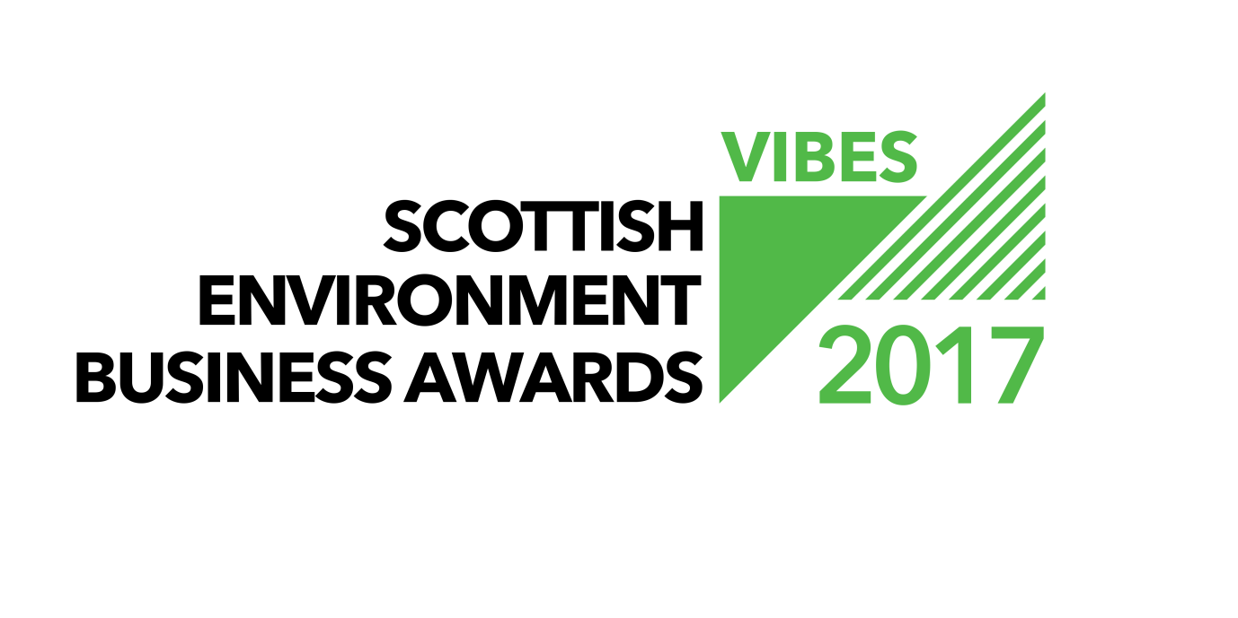

GREEN TEAM AWARD

APPLICATION FORM

2017

Contents

1. General Information 2
2. Entry Form 3
3. Additional Award Categories 5
4. What next? 7
5. EBAE Awards 7
6. Partners & Sponsors 7
7. Submission Details 9

General Information

Welcome to the VIBES – Scottish Environment Business Awards 2017. The awards aim to emphasise that best environmental practice is not only good for business, the economy and competitiveness, but that it also benefits the surroundings in which we work, live and relax. VIBES rewards those who have addressed sustainable¹ development issues in the work place and encourages others to follow their examples.
¹ “Development that meets the needs of the present without compromising the ability of future generations to meet their own needs” (Bruntland Report definition) i.e. takes consideration of social, economic and environmental issues.
The Green Team Award rewards organisations that have recognised the importance of working as a team to deliver environmental improvements. A green team can be within an organisation or between organisations.
This award can apply to organisations (public and private sector) or collaboration between different organisations to achieve efficiencies.
- A successful green team comprises people from different departments and levels of seniority. This helps to ensure that ideas are varied and dynamic.
- They require senior management support to enable their recommendations and improvements to be implemented and also to have time within their work to dedicate to the green team.
- A key attribute needed from green team members is enthusiasm
- Team members do not have to be ‘green’. Indeed, those who understand the commercial imperative of resource efficiency can be powerful in motivating others to act who have similar attitudes.
Benefits that a green team can offer can include:
- Cost savings – reducing costs associated with waste, energy, and water.
- Attracting and retaining talent – Transferable skills, improves employee morale and satisfaction, reduces staff absenteeism.
- Influences others – at work, at home and their communities
- Customer expectations and demands – strengthening brand and increasing market share.
- Regulatory compliance – staying ahead of legislation.
- Aligning practices with values – walking the talk.
- Sharing best practice – within the organisation and to a wider audience.

Entry Form
Company Name
Candidate site*
Number of sites*
Number of employees at site*
Is your company part of a larger group?*
If yes, please provide the name of the larger group*
Number of employees in group*
Are you classed as a small to medium sized enterprise (SME)?**
Have you applied for a VIBES award previously?
If ‘yes’, when and which award(s)?
Where did you hear about the VIBES – Scottish Environment Business Awards?
* This information must be completed for a successful application
** SMEs are defined as having less than 250 employees.

Main Business Activities
Please describe briefly the main business activities taking place at the site.

This section should include details of your main business activity, the services or products you provide and your principal markets. This summary is limited to 100 words.

CONTACT INFORMATION
Site Contact*
Job Title*
Telephone Number*
Email Address*
Website*
Correspondence Address Including Postcode*
* This information must be completed for a successful application

GREEN TEAM
Please explain
- Why you are applying for this award
- How your green team is set up and who is involved
- How your green team has changed behaviours
- Quantify how the green team has achieved environmental, social and economic benefit.

This section is limited to 500 words.

Additional Award Categories

Do you want to apply for another award category? If so please tick the category/ categories you would like to apply for: Please provide any additional information that you think will support your application.
 | Management (Large or SME) |  | Transport
 | Environmental Product or Service |  | Circular Economy
 | Innovation |  | Hydro Nation
Information to support additional award category/ categories
This section is limited to 500 words per category.

What next?

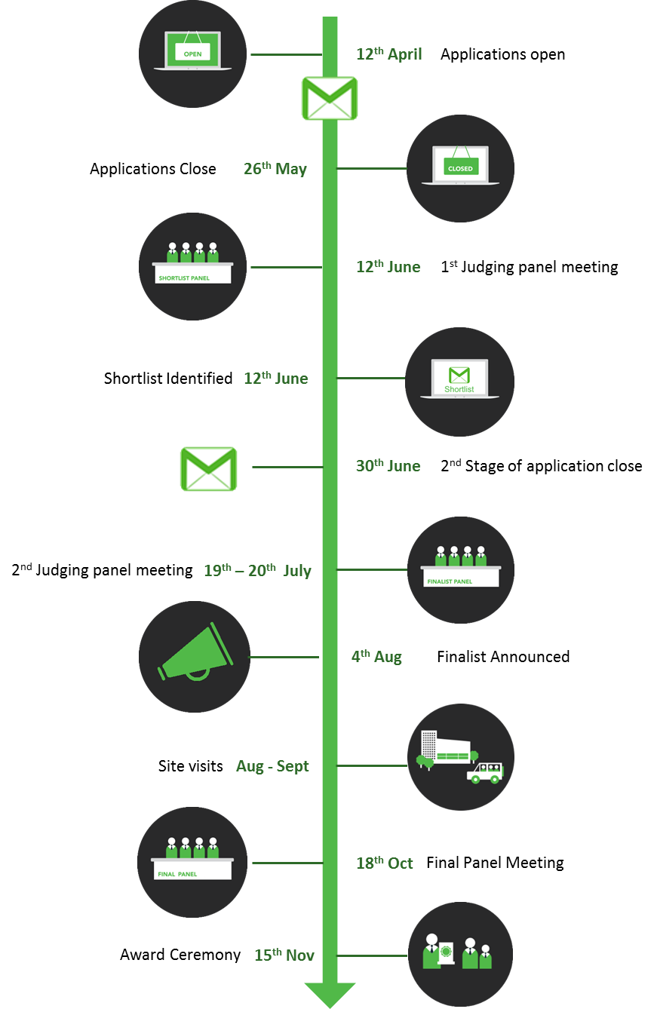
All the forms we receive will be assessed, and those which can demonstrate how their Green Team has achieved environmental, social and economic benefits and have reached the appropriate standard will be shortlisted and invited to provide further information.
This information will be reviewed and those businesses that can demonstrate the commitment and impact of the Green Team will be placed on the list of finalists. If you are placed on the list of finalists you will then receive a judge’s site visit. This gives you the opportunity to provide more details of your achievements and allows the judges to more accurately assess your application.
If your company has previously applied for or won a VIBES award, it is important that you can demonstrate continuous or additional improvement from the time of your previous application.
Please note we are limiting the shortlist to a maximum of 10 per category and the finalists to a maximum of 5 per category for 2017.

EBAE Awards

These awards act as a participating feeder scheme for the European Business Awards for the Environment (EBAE).
If you are successful with your VIBES – Scottish Environment Business Awards entry we will provide you with further information on the EBAE. You can read more about the European awards by visiting their website at: http://ec.europa.eu/environment/awards/index.html.
AWARDS
Are you happy for your application to be put forward as a potential UK entry for EBAE?

Partners & Sponsors

Please note that by entering VIBES – Scottish Environment Business Awards you agree to share the information you provide with the partner organisations for judging purposes.
We may ask partner organisations for additional information. This information will only be used to help assess your suitability as a VIBES – Scottish Environment Business Awards winner.
If you’re successful with your entry, we will prepare a case study to highlight the areas of your business that particularly impressed the judges. Once you have approved the content of the case study, it will be used to promote good practice more widely.
The partner organisations are:
- Energy Saving Trust
- Highlands and Islands Enterprise
- Scottish Environment Protection Agency
- Scottish Enterprise
- Scottish Water
- Scottish Government
- Zero Waste Scotland
- 2020 Climate Group
The Awards are supported by:
- CBI Scotland
- Institute of Directors
- Bright Green Business
- FSB
- Quality Scotland
Partner organisations, sponsors and supporting organisations may contact you with further information that they consider may be appropriate. Please indicate if you do not want to receive this information.
Please mark if you do not wish to receive information from partner organisations. | ☐
Please mark if you do not wish to receive information from sponsor organisations. | ☐
Please mark if you do not wish to receive information from supporting organisations. | ☐

Have you had contact with any of the VIBES – Scottish Environment Business Awards partners in the past?
If ‘yes’, please elaborate.

Submission Details

Forms can be downloaded as a Word document from www.vibes.org.uk, completed electronically and submitted via e-mail to vibes@sepa.org.uk.
We encourage email entries, although you may prefer to complete forms manually. Please endeavour to write as clearly as possible and send paper copies to the address at the back of the form.
To submit your completed application, save this word document using your company as the file name (if saving as PDF, please also provide a Word version). Then electronically submit this to us at the email address below.
Email Submission
vibes@SEPA.org.uk
Further Assistance
Help Desk 0300 0996699
vibes@sepa.org.uk
www.vibes.org.uk
Scottish Environment Protection Agency
VIBES Awards
Burnbrae
Mossilee Road
Galashiels
TD1 1NF

Good luck from the whole team!

