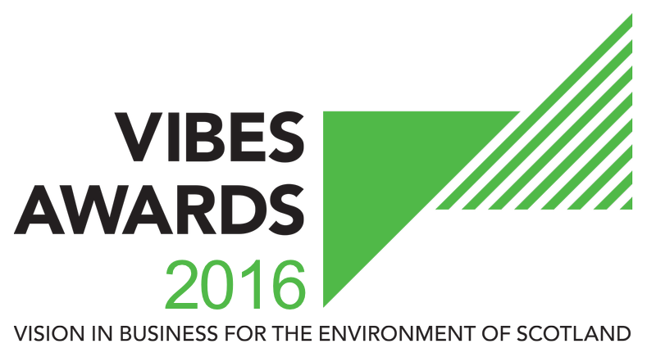

GREEN TEAM AWARD

APPLICATION FORM

2016
Contents

1. How Does It Work? 3
2. Basic Information 5
3. Judging Criteria 8
4. Partners & Sponsors 9
5. Submission Details 9

How Does It Work?

The VIBES (Vision in Business for the Environment of Scotland) Awards aim to raise awareness of environmental and sustainable development¹ issues within businesses in Scotland.
¹ “Development that meets the needs of the present without compromising the ability of future generations to meet their own needs” (Bruntland Report definition) i.e. takes consideration of social, economic and environmental issues.
The competition emphasises that best environmental practice is not only good for business, the economy and competitiveness, but that it also benefits the surroundings in which we work, live and relax. VIBES rewards those who have addressed sustainable development issues in the work place and encourages others to follow their examples.
Green teams are cross‐functional groups of employees who come together to educate, inspire and empower employees around sustainability. They identify and implement specific solutions to help their organisation operate in a more environmentally sustainable fashion. Green teams focus on greening operations at the office, addressing such issues as recycling in the office, composting food waste, reducing the use of disposable containers and eliminating plastic water bottles. Green teams will also work to integrate sustainability into employees’ personal lives,
The Green Team Award rewards organisations that have recognised the importance of working as a team to deliver environmental improvements. A green team can be within an organisation or between organisations.
This award can apply to organisations (public and private sector) or collaboration between different organisations to achieve efficiencies.
- Successful green teams comprise people from different departments and levels of seniority. This helps to ensure that ideas are varied and dynamic.
- A key attribute needed from green team members is enthusiasm.
- Team members do not have to be ‘green’. Indeed, those who understand the commercial imperative of resource efficiency can be powerful in motivating others to act who have similar attitudes.
Benefits that a green team can offer can include:
- Cost savings – reducing costs associated with waste, energy, and water.
- Attracting and retaining talent – Transferable skills, improves employee morale and satisfaction, reduces staff absenteeism.
- Influences others – both at work and at home
- Customer expectations – strengthening brand and increasing market share.
- Regulatory compliance – staying ahead of legislation.
- Aligning practices with values – walking the talk.
- Sharing best practice – within the organisation and to a wider audience.
This award will be evaluated on the following:
- Identification of green team and evidence that this includes staff from all levels within the organisation with demonstration of buy-in from senior management.
- Identification of written policy, responsibilities and targets for green team agreed with senior management.
- Examples of initiatives actioned by the Green Team that have impacted on the sustainability of the organisation and/or on employees’ personal lives.
- Evidence that the green team communicates effectively with the organisation and raises employee awareness of initiatives being undertaken.
- Evidence of wider benefits e.g. staff motivation, reduction in absenteeism, influencing others to embrace sustainability at work and at home.
Forms can be downloaded as a Word document from www.vibes.org.uk, completed electronically and submitted via e-mail to vibes@sepa.org.uk.
We encourage email entries, although you may prefer to complete forms manually. Please endeavour to write as clearly as possible and send paper copies to the address at the back of the form.
All the forms we receive will be assessed, and those which show a high level of commitment and have reached the appropriate standard will be added to the list of finalists.
If you are placed on the list of finalists, you will then receive a judges’ site visit. This gives you the opportunity to provide more details of your achievements and allows the judges to more accurately assess your application.
If your company has previously applied for or won a VIBES award, it is important that you can demonstrate continuous or additional improvement from the time of your previous application.
Please note we are limiting the finalists to a maximum of 5 per category for 2016.

Basic Information
Company Name
Candidate site*
Number of sites*
Number of employees at site*
Is your company part of a larger group?*
If yes, please provide the name of the larger group*
Number of employees in group*
Are you classed as a small to medium sized enterprise (SME)?**
* This information must be completed for a successful application
** SMEs are defined as having less than 250 employees.

Main Business Activities
Please describe briefly the main business activities taking place at the site.

This section should include details of your main business activity, the services or products you provide and your principal markets. This summary is limited to 100 words.

CONTACT INFORMATION
(please identify the leader for your green team)
Site Contact*
Job Title*
Telephone Number*
Email Address*
Website*
Correspondence Address Including Postcode*
* This information must be completed for a successful application

These awards act as a participating feeder scheme for the European Business Awards for the Environment (EBAE).
If you are successful with your VIBES entry we will provide you with further information on the EBAE. You can read more about the European awards by visiting their website at: http://ec.europa.eu/environment/awards/index.html.
AWARDS
Are you happy for your application to be put forward as a potential UK entry for EBAE?
Have you applied for a VIBES award previously?
If ‘yes’, when and which award(s)?
Where did you hear about the VIBES Awards?

Please note that by entering VIBES you agree to share the information you provide with the partner organisations for judging purposes.
We may ask partner organisations for additional information. This information will only be used to help assess your suitability as a VIBES winner.
If you’re successful with your entry, we will prepare a case study to highlight the areas of your business that particularly impressed the judges. Once you have approved the content of the case study, it will be used to promote good practice more widely.

The partner organisations are:
- Energy Saving Trust
- Highlands and Islands Enterprise
- Scottish Environment Protection Agency
- Scottish Enterprise
- Scottish Water
- Scottish Government
- Zero Waste Scotland
- 2020 Climate Group
The Awards are supported by:
- CBI Scotland
- Institute of Directors
- Bright Green Business
- FSB
- Quality Scotland
Partner organisations, sponsors and supporting organisations may contact you with further information that they consider may be appropriate. Please indicate if you do not want to receive this information.
Please mark if you do not wish to receive information from partner organisations. | ☐
Please mark if you do not wish to receive information from sponsor organisations. | ☐
Please mark if you do not wish to receive information from supporting organisations. | ☐

Judging Criteria

GREEN TEAM
Please explain why you are applying for this award providing:
- Background on the set-up of your green team and evidence that this includes staff from all levels within the organisation with demonstration of buy-in from senior management.
- Information relating to the written policy, or action plan responsibilities and targets for your green team as agreed with senior management.
- Examples of initiatives actioned by the Green Team that have impacted on the sustainability of the organisation and/or on employees’ personal lives.
- Evidence that the green team communicates effectively with the organisation and raises employee awareness of initiatives being undertaken.
- Evidence of wider benefits e.g. staff motivation reduction in absenteeism, influencing others to embrace sustainability at work and at home.
This section is limited to 500 words.

Partners & Sponsors

Have you had contact with any of the VIBES Awards partners in the past?
If ‘yes’, please elaborate.
Are you happy for VIBES partners and sponsors to contact you in the future to offer advice/support?

Submission Details

To submit your completed application, save this word document using your company as the file name (if saving as PDF, please also provide a Word version). Then electronically submit this to us at the email address below.

Email Submission
vibes@SEPA.org.uk

Further Assistance
Help Desk 0300 0996699
vibes@sepa.org.uk
www.vibes.org.uk
Scottish Environment Protection Agency
VIBES Awards
Burnbrae
Mossilee Road
Galashiels
TD1 1NF

VIBES is a partnership between
Energy Saving Trust
Highlands and Islands Enterprise
Scottish Environment Protection Agency
Scottish Enterprise
Scottish Water
Scottish Government
Zero Waste Scotland
2020 Climate Group
VIBES is supported by
CBI Scotland
Institute of Directors
Bright Green Business
FSB
Quality Scotland

Good luck from the whole team!

